***Package Placement on Conveyor***

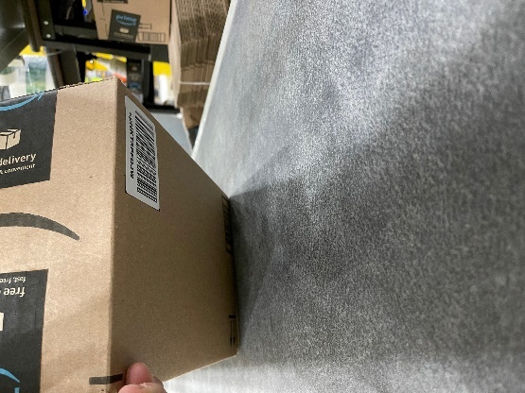 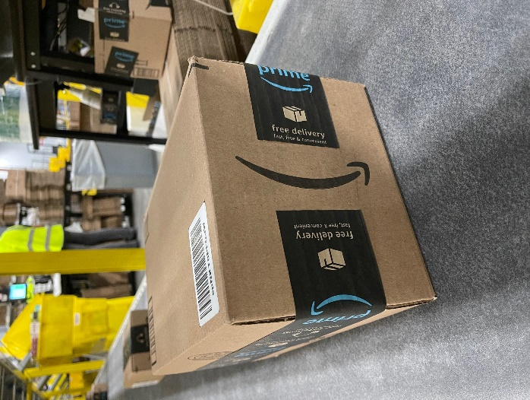

**WRONG WAY RIGHT WAY (BEST)**

**SP00 Label cannot be on bottom. Tall skinny boxes on side with SP00 label on top.**

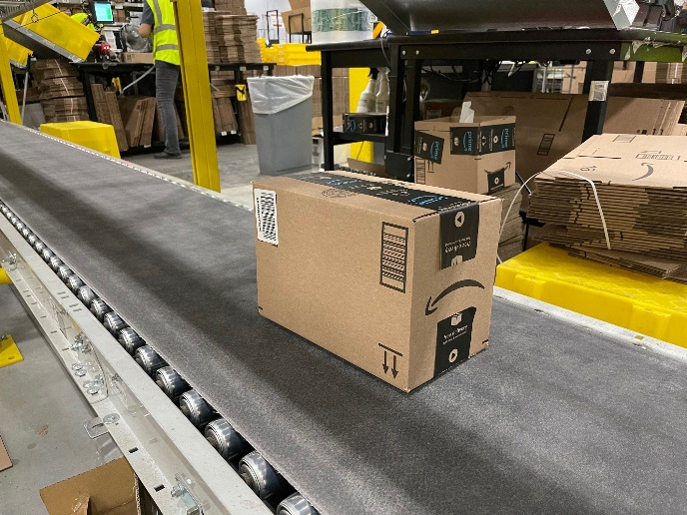

**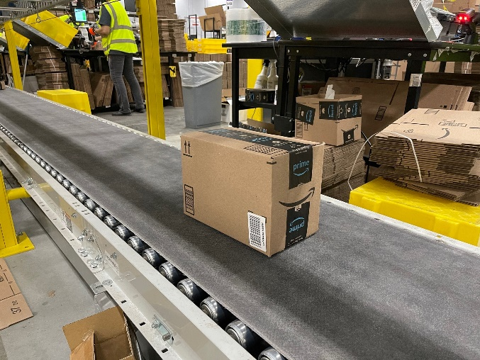  
 WRONG WAY RIGHT WAY**

**Box Frown is bad. Tall Box; SP00 is too high. Box Smile is good. Cameras are mounted close to conveyor.**

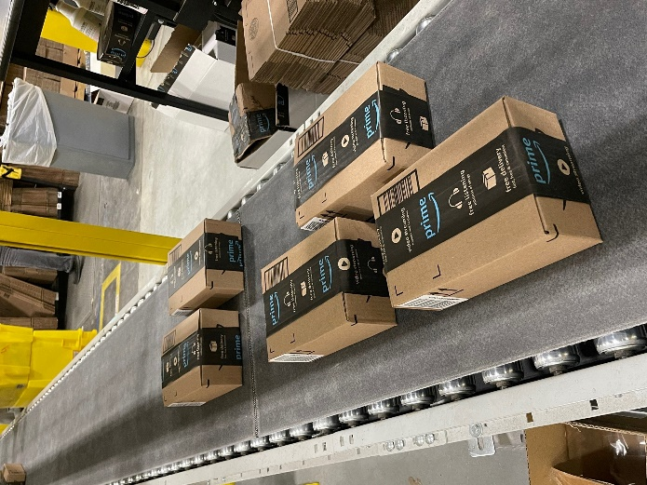 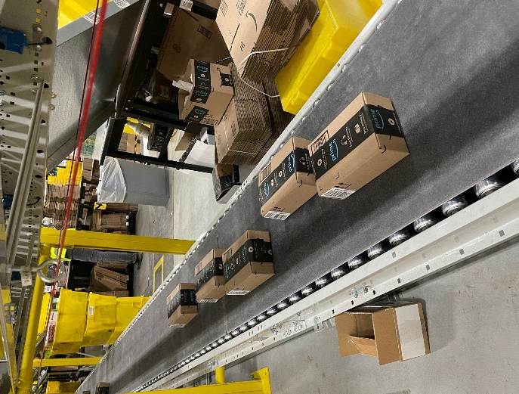

**WRONG WAY RIGHT WAY**

**Side by side will not get a label. Single File Please**

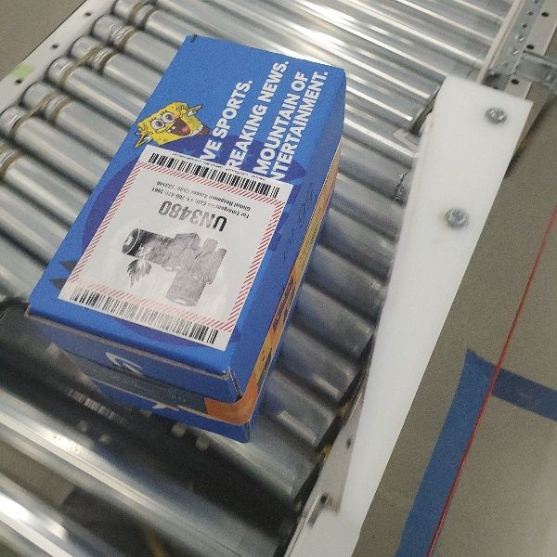 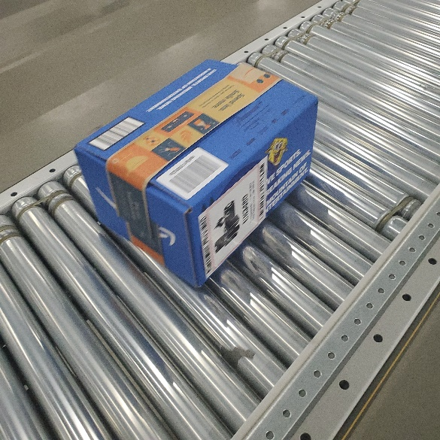

**WRONG WAY RIGHT WAY**

**Hazmant facing wrong way. Hazmant must always be facing sideways**